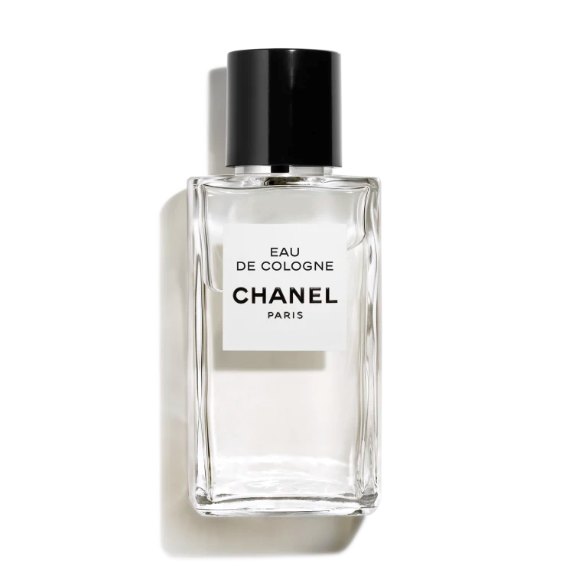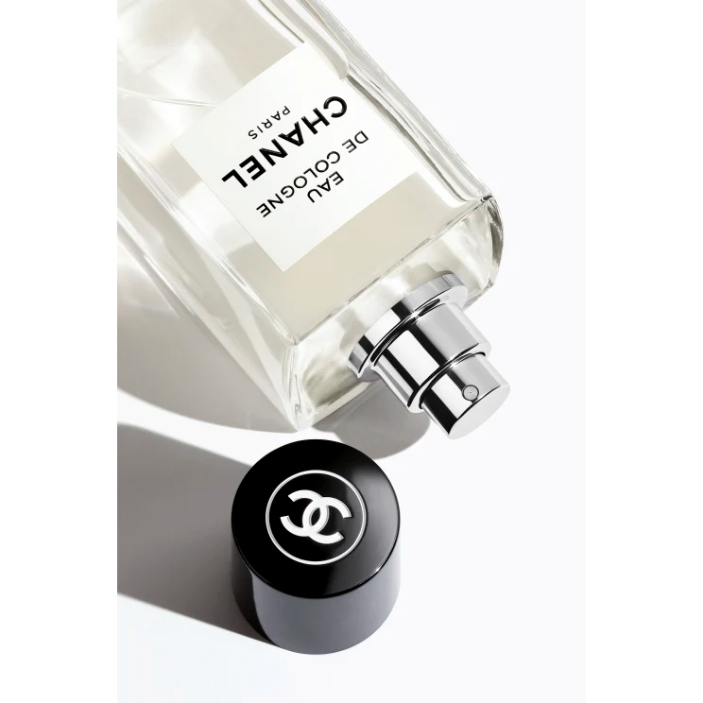

**EAU DE COLOGNE**

**$400**

Tax Included.

Spray 100 mL

IN STOCK

**Product Details**

Tan iconic symbol of elegance and simplicity through the ages, this light and solar fragrance evokes a bouquet of wildflowers. Composed by Jacques Polge—Creator of CHANEL Fragrance from 1978 to 2014—this exquisite interpretation reveals the lively freshness of mandarin and bergamot, with airy notes of neroli.